**Create ChatBot Using Python :**

There was so many ways to create a chatbot using python. So, I used Google colab for creating a chatbot using python.

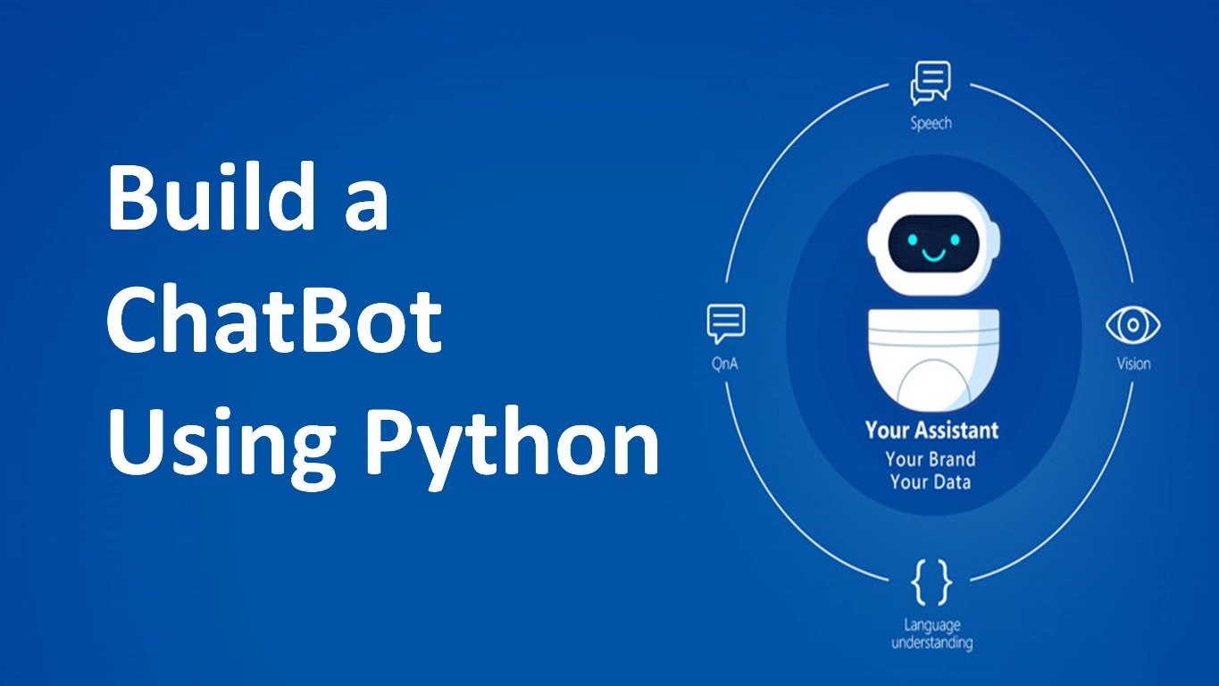

Used Framework or Library

- **NLTK (Natural Language Toolkit**) : A library for working with human language data, providing easy-to-use interfaces for tasks like tokenization, stemming, tagging, parsing, and more.

- **spaCy** : Another NLP library that's more focused on providing industrial-strength, highly optimized NLP tools.

- **Rasa :** An open-source framework for building conversational AI. It provides tools to handle NLU (Natural Language Understanding) and dialogue management.

- **Chatterbot** : A library for creating chatbots in Python which uses a selection of machine learning algorithms.

- **Dialogflow (formerly API.ai)** : A cloud-based NLP platform that provides a set of tools for building conversational interfaces.

Install Dependencies : **pip install rasa**

Project Output ScreenShot :

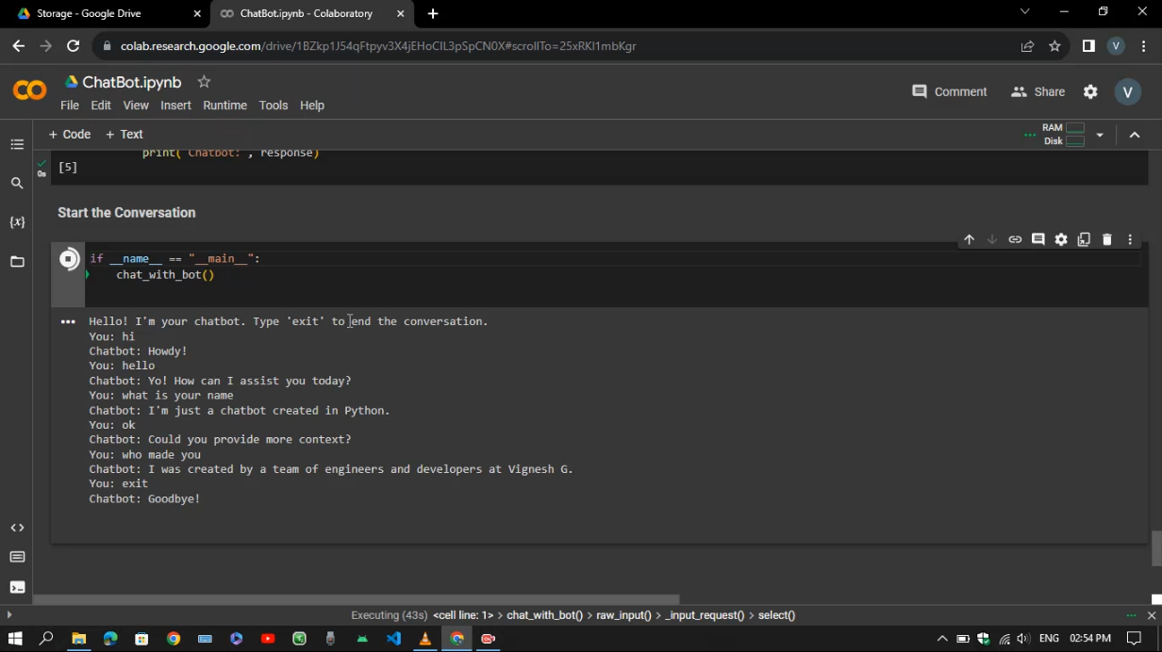

**Project Link Github :**

[*https://github.com/Sweety-Vigneshg/ChatBot-using-Python/tree/main/ChatBot%20using%20Python*](https://github.com/Sweety-Vigneshg/ChatBot-using-Python/tree/main/ChatBot%20using%20Python)

**DataSet Link :**

[*https://github.com/Sweety-Vigneshg/ChatBot-using-Python/tree/main/ChatBot%20using%20Python/Dataset*](https://github.com/Sweety-Vigneshg/ChatBot-using-Python/tree/main/ChatBot%20using%20Python/Dataset)

**Video Demo :**

[*https://github.com/Sweety-Vigneshg/ChatBot-using-Python/tree/main/ChatBot%20using%20Python/Report%20and%20Video%20Demonstration*](https://github.com/Sweety-Vigneshg/ChatBot-using-Python/tree/main/ChatBot%20using%20Python/Report%20and%20Video%20Demonstration)

**Source Code :**

[*https://github.com/Sweety-Vigneshg/ChatBot-using-Python/tree/main/ChatBot%20using%20Python/Training*](https://github.com/Sweety-Vigneshg/ChatBot-using-Python/tree/main/ChatBot%20using%20Python/Training)

*Project Submitted By*

*Vignesh G*

[*814621104059@trichyengg.ac.in*](mailto:814621104059@trichyengg.ac.in)

*Computer science and Engineering*